Executive Summary

Purpose
The purpose of this report is to identify listing factors that strongly predict price to charge for a first-time host aiming to set an appropriate initial nightly rate for a rental in New York City.

Minimal Background
A homeowner in New York City is attempting to find an appropriate price to charge for their accommodation on Airbnb for the first time. First-time Airbnb hosts face uncertainty when setting an initial nightly rate. To find data-driven factors that drive pricing, data analysts look at 8 independent variables to determine which are linked to nightly pricing. Using exploratory data analysis, correlation testing, and regression modelling, this report provides data-driven evidence to support the decision making process for a competitive and appropriate Airbnb rental rate.

Finding and Results
The final results identified two variables that strongly correlated with price:
- Guest Capacity (Accommodates): Listings that can accommodate more guests are able to charge higher prices than listings that host fewer. This suggests that the number of guests who use space is related to pricing.
- Borough Location: Particularly in NYC, the location of the Airbnb matters to guests, and homeowners in locations such as Manhattan are able to charge higher rates compared to other boroughs. This indicates a strong relationship between location and price.

Recommendations

First Recommendation : Use capacity and location as the baseline for price.
It is recommended to utilize the number of guests accommodated and the borough location as initial price drivers. Capacity and location are the most strongly related amongst the identified variables which create a strong starting point for finding an appropriate price.

Second Recommendation : Adjust price based on seasonality and local events.
An additional factor to consider not identified within this report is time of year. Time of year includes seasonality, weather, and holidays. Similarly, keeping up with local events can give the host an advantage by adjusting prices when a high volume of visitors are expected to be in the same area as the listing.

Introduction
This report identifies the main factors that predict nightly Airbnb rental prices in New York City. Airbnb is an online marketplace in over 81,000 cities that connects guests seeking an available room or home from someone who owns vacant property. To examine the correlation between Airbnb nightly price and 8 independent variables related to listing, a snapshot of data from March 2025 is analyzed using multiple linear regression.

Purpose
The purpose of this report is to identify listing factors that strongly predict price to charge for a first-time host aiming to set an appropriate initial nightly rate for a rental in New York City.

Background Details
This analysis is presented to support pricing strategy decisions for a New York City home being listed on. Airbnb is a global online marketplace founded in 2008 that allows property owners to rent out their private spaces. This website revolutionized travel by shifting focus from staying in hotels on vacation, to relaxing in the comfort of a home with a kitchen at a lower price. A first time host entering this market faces the challenge of setting a nightly rate that is both competitive and reflective of the listing’s value.

Group 4 Consulting, a group of data analysts, were asked to provide data-driven evidence to find how existing listing characteristics relate to price rates of Airbnb rentals. To accomplish this, independent variables such as beds, bathrooms, room type, borough, accommodates, availability, minimum nights, and review, were drawn from existing Airbnb data from March 2025. The goal is to observe market patterns amongst these variables and aid in the decision making process for a first-time Airbnb property user.

The first step in pricing analysis is having reliable and relevant data. Airbnb listing data was extracted and converted into spreadsheet format. With this raw data set, data cleansing techniques were applied to excluded cells that would compromise the accuracy of statistical outputs. To narrow down the data, a snapshot of March 2025 listings were taken. These steps reduced the original dataset of approximately 37,000 listings to a working sample of about 1,100 to more precisely identify price drivers.

Data Source and Related Information
To answer the question of what nightly price would be appropriate to charge for an Airbnb rental in New York City, the analysis began by building a clean, comparable dataset through a process of data cleansing. First, the Data Dictionary tab is reviewed to understand what each field means and how it should be interpreted. Then, the following cleaning decisions were applied:

Step 1 | Bathroom counts were corrected using the “Text to Columns” feature with a delimiter which isolates the numeric bathroom count to a separate column. Non-numeric and blank bathroom entries were filtered out and deleted.
Step 2 | Dataset was filtered to only March 2025 reviews. All rows outside of this date range were filtered and deleted.
Step 3 | Blank cells in Bedroom were set to zero, as studio listings may have no separate bedroom.
Step 4 | Bed rows that contained blanks or zeros in were deleted.
Step 5 | Availability was filtered to at least 30 days to reflect a sample of rentals that are readily accessible and is meaningful for pricing purposes.
Step 6 | Hotel Rooms and Shared Rooms were excluded as this analysis focuses on home/apartment and private room listings.
Step 7 | Minimum nights were capped at 30 nights, as long stay rentals aren’t as comparable to regular short-term rental prices.
Step 8 | Nonnumeric variables were assigned numerical values as required by Excel’s regression tool.
Step 9 | Finally, features are recorded from nonnumeric to numeric variables such as classifying Boroughs in codes with 4 for Manhattan, 2 for Brooklyn, and 1 for all other borrows.

After applying the mentioned cleaning steps, the data set is reduced. The sample began with roughly 37,000 original listenings and was refined to about 1,100 cleaned data. These numbers provide a reliable foundation for identifying price drivers and building a regression model to estimate nightly charge appropriately.

Roadmap
To estimate an appropriate nightly charge for an Airbnb rental, the initial step of data cleansing was performed. With the reliable sample, an analysis through regression models and various other data analysis techniques revealed two variables that strongly drive price and explain nearly half of variation seen across listings. The sections that follow walk through each stage of this process of how the data was collected and then analyzed to support the decisions of a first-time Airbnb user.

Data Exploration
When analyzing the pricing information for airbnb rentals in New York city, before performing regression analysis, I predicted certain factors to be more prevalent than others in affecting the listing prices.

By using descriptive statistics shown below I found the most locations for these rental properties lie in Manhattan and Brooklyn, the average price was roughly $158.71, and there is a slight skewness to the right due to higher priced locations driving up the average price.

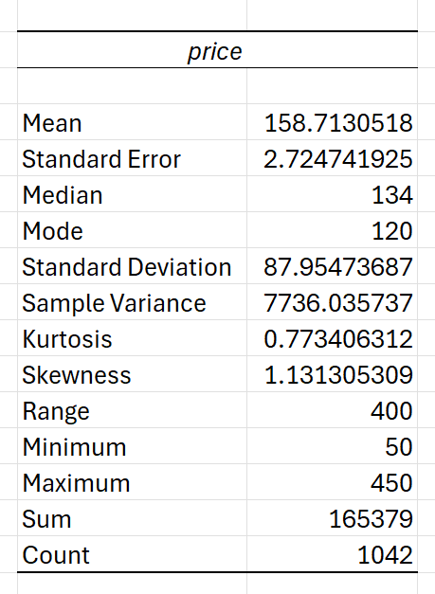
I then used a boxplot visualization to demonstrate which borough had the highest priced listings. As shown below I can confirm that Manhattan listings are the most expensive, this may be due to its proximity to tourist attractions, vivid nightlife, or for those traveling for work in the city
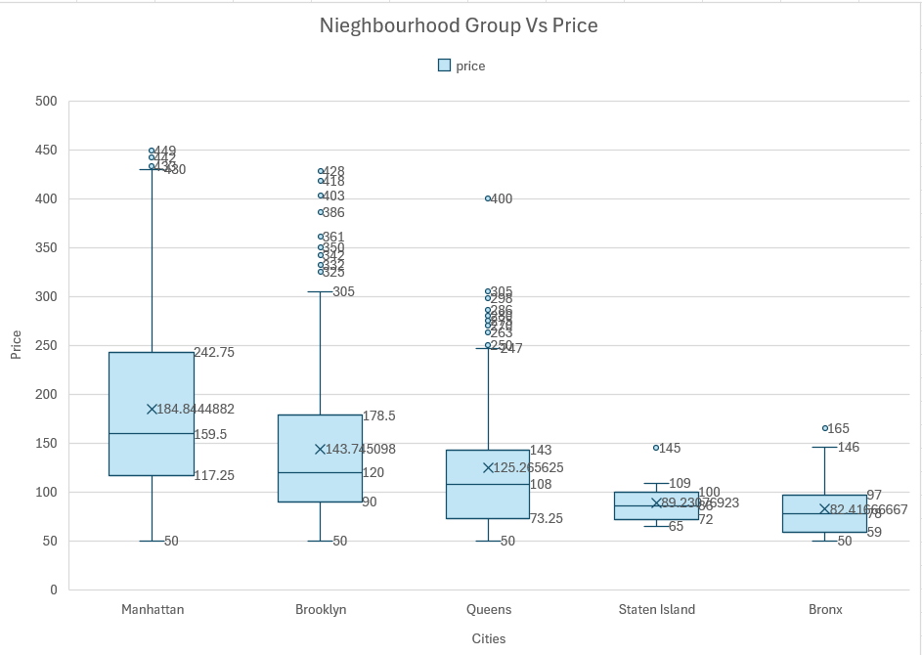
I also visually displayed the average pricing for entire homes versus private rooms in a boxplot graph. Below I can gather that private rooms are less costly, on average, than a whole property. This can be attributed to lack of physical space in a single room or having shared rooms such as bathrooms or kitchen space bringing down costs. 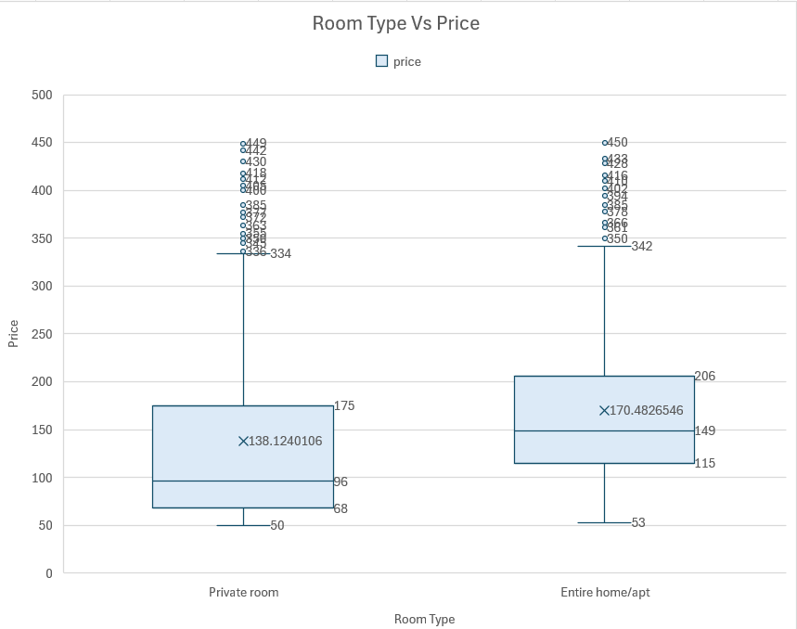

Through data cleansing I narrowed down our variables to the following; accommodates, bathrooms, beds, reviews, availability, minimum nights, room type, and borough. As for the relationships between the variables and pricing I interpreted them as follows:

Accommodates | As more accommodates are provided, pricing goes up as there are additional luxuries some choose to spend on. | Positive relationship
Bathrooms | When the number of bathrooms provided increases, so does pricing. This is because it grants more privacy for larger parties and implies a larger listing. | Positive relationship
Beds | The more beds available, the higher the price. Similar to bathrooms, it comforts larger families and grants more privacy to individuals. | Positive relationship
Reviews | As the number of reviews increases, the price lowers. Due to people being more inclined to leave a review if they’ve had a negative experience. | Negative relationship
Availability | When properties are not being booked, they have too much open availability, and so listing prices tend to be lower to appeal to the consumer. | Negative relationship
Minimum Nights | When there are higher limitations on minimum nights the price is lower, this is to entice the guest to book a certain amount of days. This would lower cleaning fees and be mutually beneficial. | Negative relationship
Private Room | — | Negative relationship
Borough | When the location is in the more coveted bigger cities, the prices are higher as there is more demand. | Positive relationship

Additionally I generated a correlation matrix to identify the strength between the relationships of variables and price. The matrix also helped identify some multicollinearity between *enter variables here*
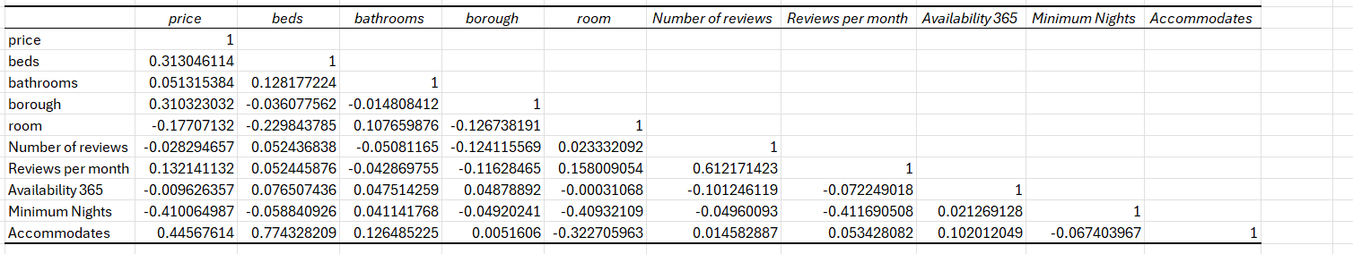

First Regression Model
When running our first regression model, shown below, price was set as the dependent variable to be affected by the independent variables such as accommodates, bathrooms, beds and so on. The analysis returned with p-values higher than that of our alpha which was set at 0.05 for the number of bedrooms, beds, reviews per month, and reviews. With those results I removed those variables as they were found to be insignificant when affecting the pricing of the properties. I were also provided with our adjusted r-squared which was calculated roughly at 0.47 to give us a base line moving forward to confirm I removed the correct variables. I proceeded to re-run our models and refine our regression equation there after.
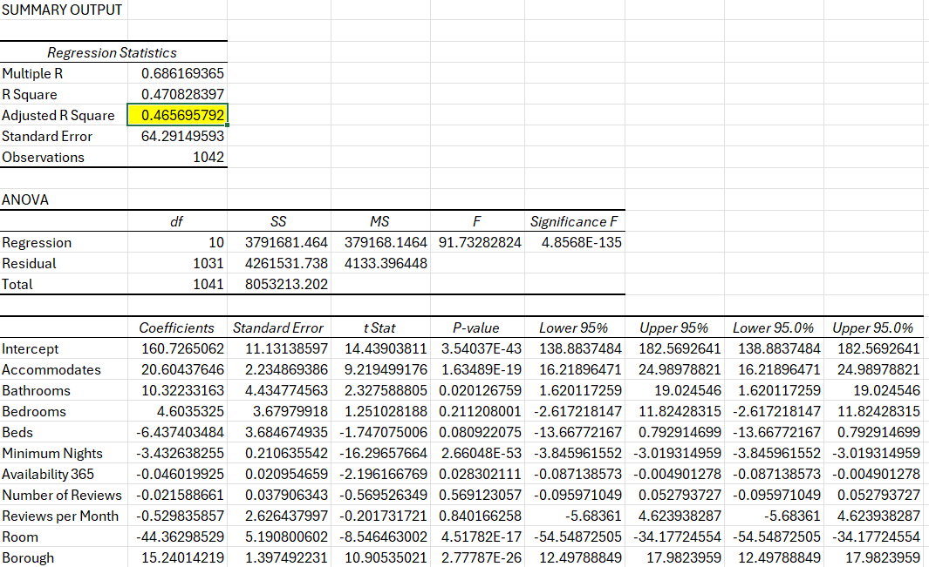

Manhattan Regression
This is a specialized version of your model focused specifically on Manhattan listings to see how well the predictive variables perform in the city's most expensive market.
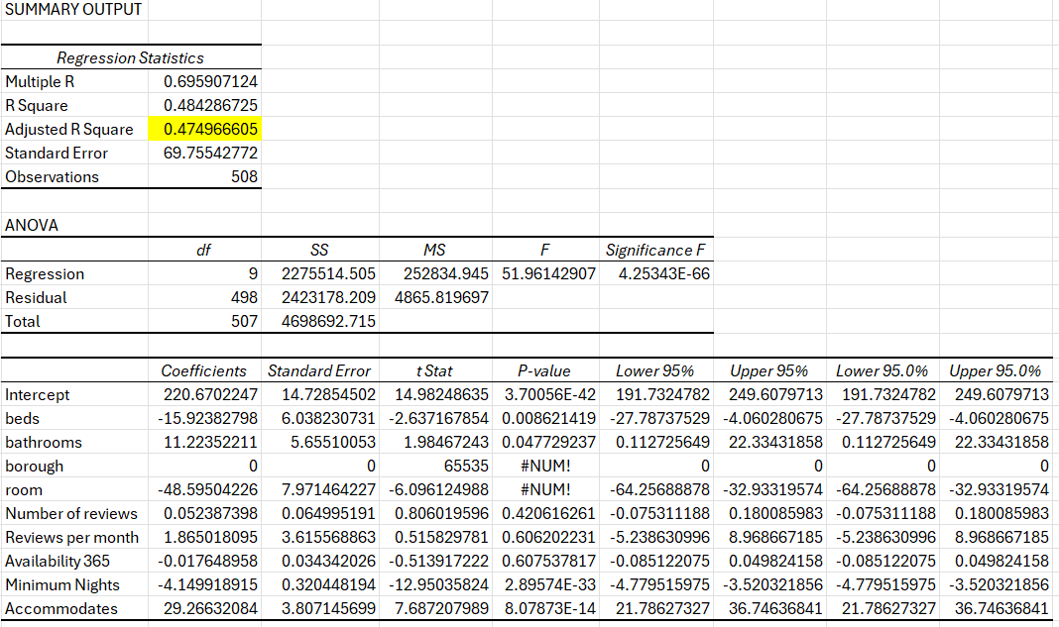

Actual Price Vs Estimated Price:
I performed a validation step by directly comparing a group of 10 random real listing prices against the values predicted by your regression model to assess accuracy. Below is a visualization demonstrating the comparison between our predicted pricing and actual.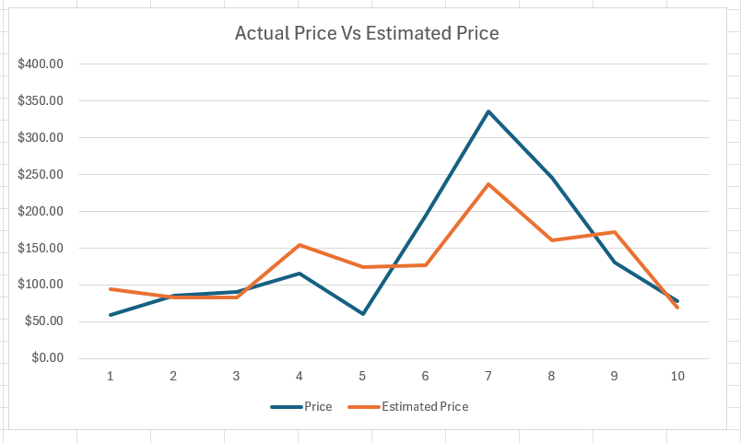
Conclusion
After performing multiple regression and several data analytic techniques, Group 4 Consulting arrived at the conclusion that New York City Airbnb nightly rates are primarily driven by capacity and location. The descriptive patterns in our models indicate that Accommodates (capacity) and Borough (location) are the strongest predictors that correlate the most with nightly price. Listings within the Manhattan and Brooklyn neighborhoods tend to command a higher price than the other boroughs.

Secondarily to those variables, Room Type had a less significant relationship to price, but revealed that private rooms tended to be priced lower in comparison to entire homes. This suggests that two listings with similar capacity and in the same location, can still be priced differently from each other. Guests would be paying a higher premium for access to an entire home, while private rooms would be a much lower cost-option to them.

Overall, a good pricing approach for a first-time Airbnb host is to consider the number of guests their home may accommodate together with the general location of their listing. If the host is located in either Manhattan or Brooklyn, then they would have the advantage of a higher starting baseline price. Along with more recommended variables that were not observed in the report, this approach towards pricing using the number of guests accommodated and location of the borough can be used to accurately set a value for their initial listing.

Recommendation
Group 4 Consulting recommends to begin with the two factors that most consistently explain the difference in nightly rates: how many guests the space can host and the location of the listing. Listings with higher capacity that can accommodate more guests can justify a higher base rate. Borough location also provides an advantage and a way to gauge the price of surrounding areas. Particularly, if the listing is located in Manhattan or Brooklyn, then the listing can usually have an even higher starting price than a location with less demand.

Once the baseline is set, I recommend to continue to fine tune pricing with features that affect perceived value, such as room type, number of bathrooms, and bed layout. That can be expanded upon further by observing seasonality and holidays. After observing the pattern of vacationers to NYC, a host could leverage time of year and have different pricing during peak-visitation times versus ordinary time. In addition, having awareness of what local events happen can create more variation in the price. Concerts, Sporting events, and similar are expected to bring more visitors to a specific area which a host can use to adjust pricing as well.

Works Cited

Carnehl, Christoph, et al. “Value for Money and Selection: How Pricing Affects Airbnb Ratings.” SSRN Electronic Journal, 2022, https://doi.org/10.2139/ssrn.4207034.

Wei, Leo. “New York Airbnb Price Prediction: A Data-Driven Analysis.” Medium, 31 Mar. 2025, medium.com/@weihanjun.leo/new-york-airbnb-price-prediction-a-data-driven-analysis-77d3c6d05f45.
‌

‌

